 **ANNA UNIVERSITY** 

**NAAN MUDHALVAN – GUIDED PROJECT**

**BRAINSTROMING**

**TRANSPARENT EDUCATION DATA MANAGEMENT**

|  |  |
| --- | --- |
| DATE | 31 OCTOBER 2023 |
| TEAM MEMBERS WITH NM ID | 1. LAVANYA M  E5260COOBE1507F9FE14D88B3D716D11 2. MAHALINGAM M E351BDD1BD50FB280F94F4A8EE60CCB3 3. MOUNISH K   D5FDEAD3A88DA8FBFBD4728465FC2747   1. NAVEEN KUMAR L   EB1A867401B7BBAB8AA43F77116A66E1 |
| PROJECT NAME | FOOD TRACKING SYSTEM USING BLOCKCHAIN TECHNOLOGY |
| COLLEGE NAME | ALAGAPPA COLLEGE OF TECHNOLOGY, ANNA UNIVERSITY |

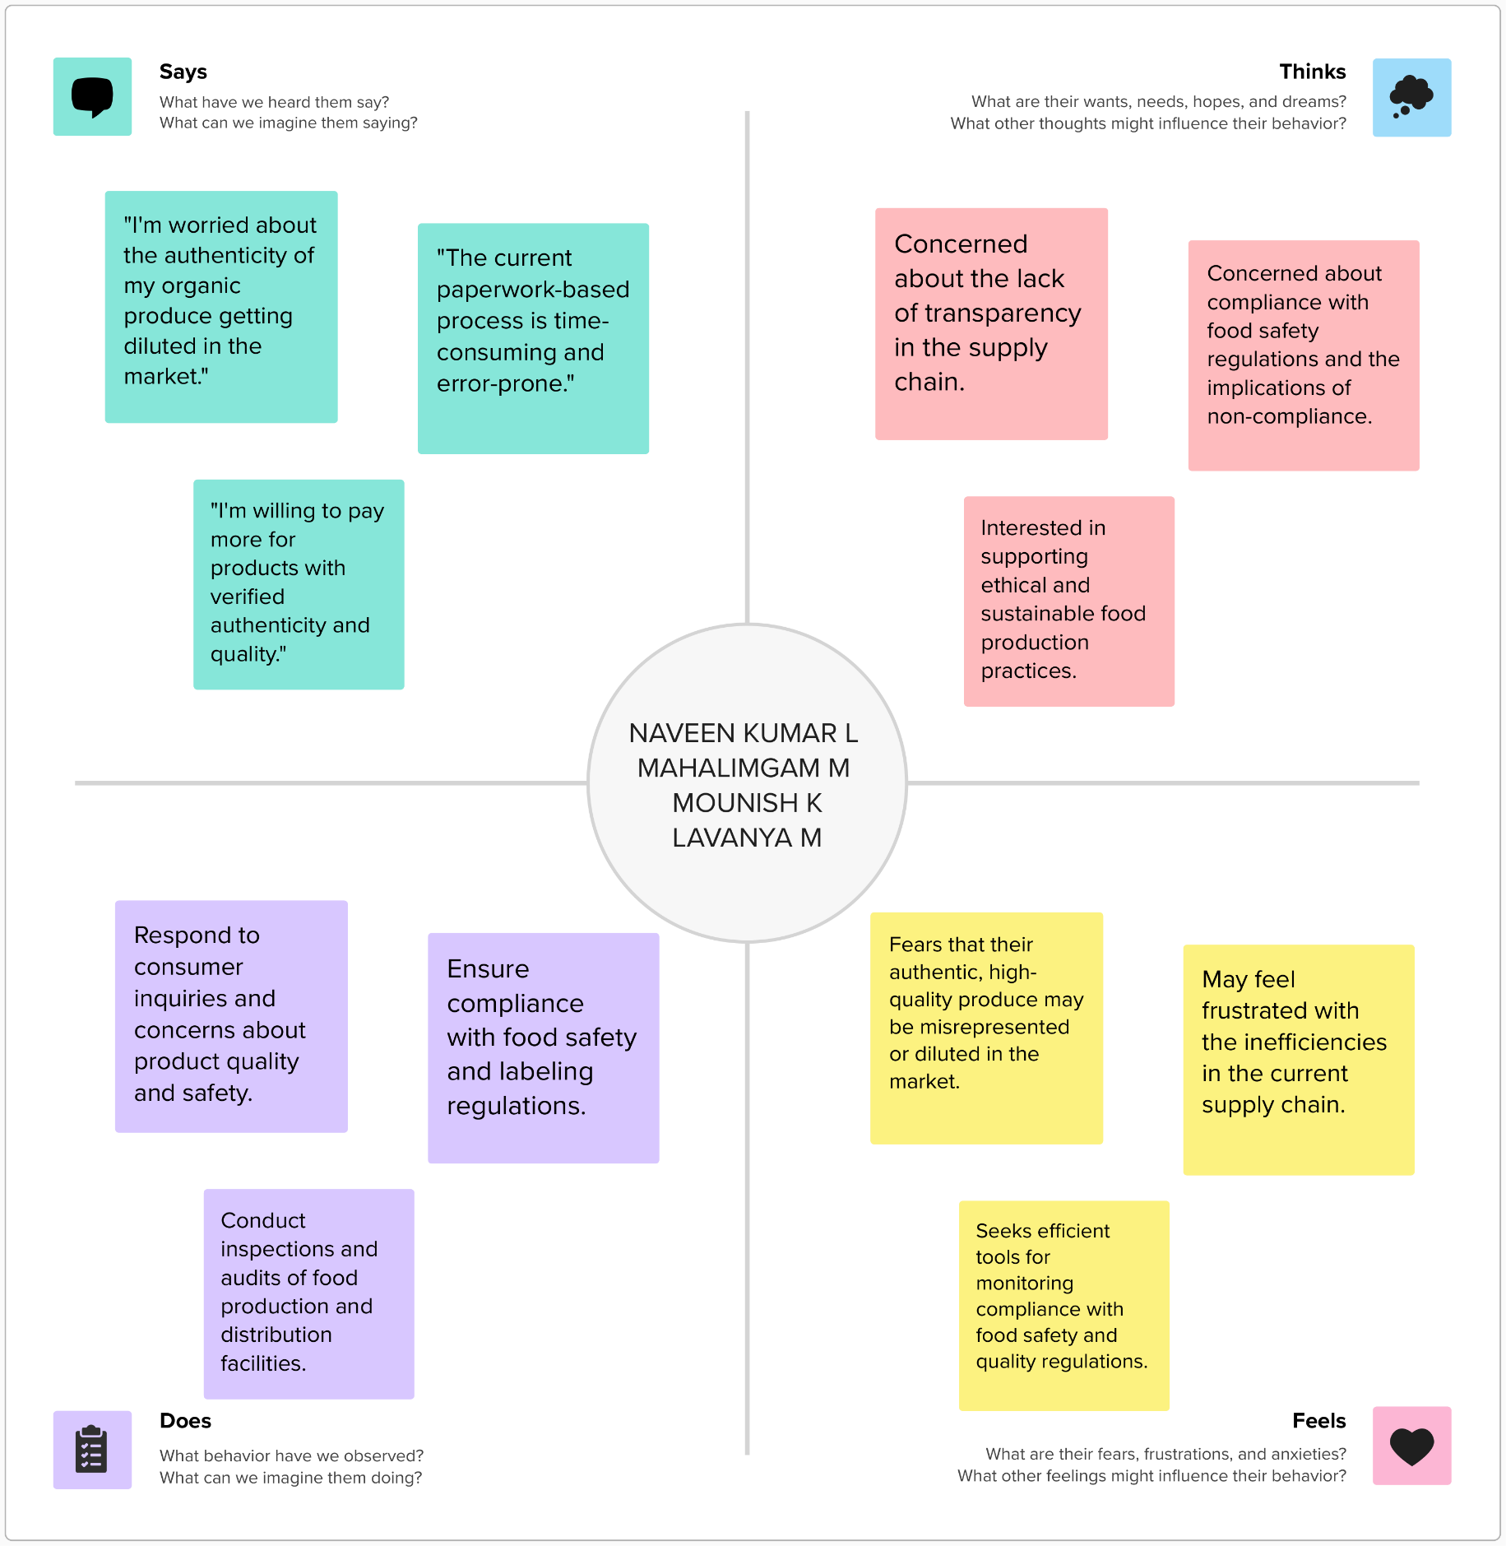**Ideation & Brainstorming:**